__________________________________________________

Intellectual Disability Sensitization & Mentoring

Proposal by

WinVinaya Foundation

To

Accenture

Date of Proposal: 13th Dec 2021

Version 1.0

Project Contact: Sivasankar Jayagopal

Founder Chairman

WinVinaya Foundation

25/3 Brindavan 3rd Cross, Saraswathipuram

IIM Post

Bengaluru 560 076

Ph.: +91-96764-33359

Email: [Shiva.Jayagopal@WinVinayaFoundation.org](mailto:Shiva.Jayagopal@WinVinayaFoundation.org)

Table of Contents

1 Background 3

2 Introduction about WinVinaya Foundation 3

3 WinVinaya’s Approach 3

3.1 Pre Recruitment Support 3

3.1.1 Disability Sensitization Workshop 3

3.1.2 Creating Buddy System 4

3.1.3 Meeting Stake Holders 4

3.2 Post Recruitment Support 5

3.2.1 First Two Weeks 5

3.2.2 Third Week 5

3.2.3 Fourth Week 5

3.2.4 Second & Third Months 6

3.2.5 Fourth Month 6

4 WinVinaya’s Experience 6

5 Assumptions 6

6 Recommended Milestones 6

7 Commercials 7

8 Thanks for the Opportunity 7

Appendix 8

# Background

Accenture is a multinational professional services company that specialises in IT services and consulting. Inclusion and diversity are fundamental to Accenture’s culture and core values. Accenture is in the process of recruiting a Person with Autism - for Infrastructure support role and want help and support in terms of sensitization, pre and post recruitment support so that both the delivery teams and the candidate are able to settle down and work seamlessly.

# Introduction about WinVinaya Foundation

WinVinaya Foundation, a Charitable Trust was registered in Feb 2016 by Sivasankar Jayagopal who is an IT Veteran with 30+ years of industry experience and Seethalakshmi (Akila) who has 17+ years of experience working with Persons with Disabilities. Our primary aim is to empower Persons with Disabilities, economically disadvantaged and women to earn a decent income and lead a life with dignity by providing life skills and resources. We operate a centre in Bangalore and a centre in Tirupur.

WinVinaya believes D&I initiatives has to be holistic and comprehensive. WinVinaya has trained candidates **across 10 disabilities** coming from 12 states**.** Akila is a special educator with extensive experience working with Persons with Disabilities especially Persons with Intellectual Disabilities (ID) and Mental Illness. She believes that “Anyone can learn” with the right methodology.

# WinVinaya’s Approach

The key stake holders in ensuring successful settling of the candidate with intellectual disorder (autism) in Accenture are the Delivery Team members, HR Team members, Job Coach, candidate’s parents/guardians and the candidate herself.

While other stake holders are known, who is JOB COACH? Job Coaches are trained professionals who act as links between the individuals with disability and the employment setting, to help the candidates to have fulfilling and satisfying work lives. They are professionals who ensure that people with disabilities join the workforce and be in sustained employment.

WinVinaya will provide the Job Coach. She will involve in both phases - pre and post recruitment of the candidate. The steps are explained in detail in this proposal.

## Pre Recruitment Support

In this phase, the Job Coach will connect with the stake holders through sensitization workshop, team discussions and meetings with the candidate and her parents/guardians.

### Disability Sensitization Workshop

Our inclusion and sensitization sessions will deliver a social and a cultural storyline to provide a complete picture in favour of creating an inclusive and accessible environment at Accenture for both the ID employee and the people she will work with – delivery team members and HR team members.

* Overall sensitization about Autism
* Candidate specific sensitization - Strengths, limitations, downs and ups

We conduct this workshop to emphasize on the joint efforts for stimulating inclusion of people with disabilities at various levels. This disability sensitization workshop will be specific on autistic disability and issues surrounding mental health and will also provide information on a range of other disabilities, including acquired disabilities, hearing and visual impairments and learning disabilities. This workshop will bring a change in the mind-set of the people and highlighting the abilities of ID candidates.

The workshop encourages employees to discuss their preconceptions of disability and their fears of interacting with people with disabilities. It leads a way toward promoting a harmonious and productive workplace environment.

**The duration of this Disability Sensitization Workshop is 2 hours.**

### Creating Buddy System

Accenture (delivery team head) will identify a ‘buddy’ at the workplace — someone with whom the candidate can share her experiences and reaches out to when required, especially if she needs help, feels any discomfort harassed, ridiculed or humiliated at the workplace. It is recommended to have minimum two buddies as the candidate can reach out to one if another is on leave or busy.

### Meeting Stake Holders

The Job Coach will virtually meet the delivery team, buddies identified, candidate’s parents and the candidate.

#### Meeting Delivery Team

The Job Coach will meet the delivery team with whom the candidate will work. The discussion points will be -

* Goal of this recruitment
* Selection Process
* Job role of the candidate
* Resume of the candidate
* Roles & Responsibilities of the candidate
* Daily activities of the candidate
* Workplace culture, rules, conditions, expectations
* Policies related to safety
* Plan for training the candidate and any relevant training material available in Accenture
* Co-workers/ buddies from Accenture who can support the candidate

This duration of this meeting will be for 2 hours. After the meeting, the Job Coach will analyse and design the individual plan (Employer - Employee relation) on the on boarding process customized for the ID candidate in collaboration with the delivery team.

#### Meeting Buddies

The Job Coach will discuss with the buddies identified -

* Understand the background of the buddies - including any experience in working with Persons with Disabilities
* Steps to integrate the candidate into the team
* Any potential issues to be addressed
* Strengths and limitations of the candidate

This duration of this meeting will be for 2 hours. The Job Coach will guide the buddies in implementing the plan created for on boarding the candidate to the team and Accenture.

#### Meeting the Candidate and the Candidate’s Parents

Parents play a vital role in the selection of a job for their Intellectually Disabled children. They have a lot of queries starting from deciding whether their child would be happy in her workplace. Over protectiveness, co-dependency and fear of the unknown are some of the concerns of the parents that need to be addressed. The Job Coach will work with the candidate and her parents on the

* Background and history of the candidate
* Triggering Elements for the candidate (color, alignments, situation)
* Calming down methodologies
* Any NGO the candidate is/was associated with
* Understand her readiness for work
* What are the anxieties they have about this job
* What kind of support they are expecting from Accenture and their inclusive partner NGO
* Whether Gender & Sexual Orientation, Relevant soft skills has been provided to the candidates and to the parents by any other organization

This duration of this meeting will be for 2 hours. Also, if the parents and the candidate are not sensitized before on Gender & Sexual Orientation at workplaces, the Job Coach will conduct this session for them. The Job Coach will also conduct few soft skills orientation (like work place etiquette, how to attend meetings, conversations with peers etc.) if required.

## Post Recruitment Support

Through our experience we have realized that, once the candidate joins Accenture, she will need some support and mentoring to ensure that the inclusive journey is successful. WinVinaya team will have meetings with the candidate and her buddies at regular intervals as listed below for four months. There will be a minimum of 25 sessions during these four months.

### First Two Weeks

During the first and second weeks after the candidate joins Accenture, the Job Coach will

* Connect the buddies with the candidate
* Create a task list, check list, work flow along with the candidate and the buddies
* Monitor the candidate to implement and practice the list
* Get feedback from the buddies and share with the candidate
* Get candidate’s inputs and guide her where required

During these first two weeks, the Job Coach will connect with the candidate daily for 30 minutes (minimum 2 hours a week).

### Third Week

During this week, the Job Coach will be a silent observer and will monitor the candidate’s progress. The Job Coach will connect with the candidate on alternate days and will also connect with buddies if required on a need basis.

### Fourth Week

In this week, the Job Coach will give feedback to the candidate and to the buddies based on her observations. The Job Coach will connect with the candidate twice during this week.

### Second & Third Months

During these two months, the Job Coach will interact with the candidate once a week.

### Fourth Month

During this last month, the Job Coach will have a fortnightly connect (twice in a month) with the candidate.

# WinVinaya’s Experience

At WinVinaya, we have experience in providing several important services to help people with developmental disabilities to find and maintain meaningful and gainful employment. We help the candidates to identify their job-related strengths and weaknesses, to make the transition from their home atmosphere to the workplace and provide required support and assistance. We provide supportive counseling to the candidate to promote interpersonal and soft skills including but not limited to recognizing social cues, accepting feedback from lead/manager, customer interaction, adhering to workplace cultures and success on the job.

When a majority of the NGOs associated with ID candidates train them in vocational training, WinVinaya Foundation focusses on training them in IT skills. While predominantly the ID candidates are trained in Data Entry skills, WinVinaya trains them in niche skills in Data Visualization - specifically in Microsoft Power BI. Some PBI reports developed by our ID candidates at WinVinaya is in Appendix.

# Assumptions

For all the sessions, the assumptions made are:

* All sessions are **online** (using Accenture approved online meeting tool).
* The maximum number of participants for the disability sensitization workshop is 15. The charges remain the same for the sessions with lesser number of participants as well.
* Accenture will organize the discussions with the ID candidate, her parents, delivery team and HR team and communicate to employees via sensitization e-mailers.
* Accenture will identify buddies for the ID candidate.
* Accenture will ensure timely payments to the vendor owing to Accenture Payment terms and conditions.

# Recommended Milestones

The high level milestones:

|  |  |  |
| --- | --- | --- |
| ACTIVITY | FREQUENCY | TIMEFRAME |
| Disability Sensitization Workshop | Once | December 2021 - 4th week |
| Pre Recruitment Support | Once with each group  (Delivery Team, Buddies, Parents & candidate) | December 2021 - 5th week |
| Post Recruitment Support | * First Two Weeks - Every day for 30 minutes * Third Week - Alternate days for 30 minutes * Fourth Week - Twice for 30 minutes * Second & Third Months - Once a week for 30 minutes * Fourth Month - Once in two weeks for 30 minutes | January 2022 - April 2022 |

# Commercials

|  |  |  |
| --- | --- | --- |
| ACTIVITY | # SESSIONS | COST |
| Disability Sensitization Workshop  15 per session (max) | Once | ₹ 25,000 |
| Pre Recruitment Support | 3 sessions with each group;  Gender & Sexual Orientation to candidate and her parents if required | ₹ 25,000 |
| Post Recruitment Support | 25 sessions (minimum) | ₹ 50,000 |

For the Workshop and the pre recruitment support, the invoice will be raised at the end of the session and meetings. For post recruitment support, the invoice will be raised at the end of fourth month.

Payment is to be done within 30 days from the invoice date. Payment is to be made by electronic transfer.

# Thanks for the Opportunity

We thank Accenture for giving us this opportunity to create awareness, sensitize the Accenture employees that will have an impact on their attitude and behavior towards their autistic colleague who they will work along and connect with ID employee to ensure that she settles down seamlessly.

# Appendix

**Sample Power BI Reports by Neuro Diversity Candidates**

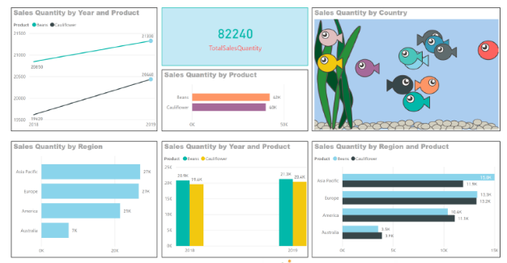

Developed by Indra Pratap Sengar (diagnosed with Schizophrenia)

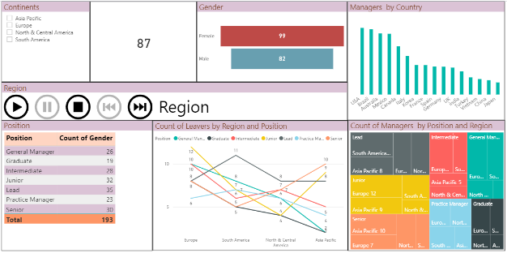

Developed by Mahendra (diagnosed with Autism)

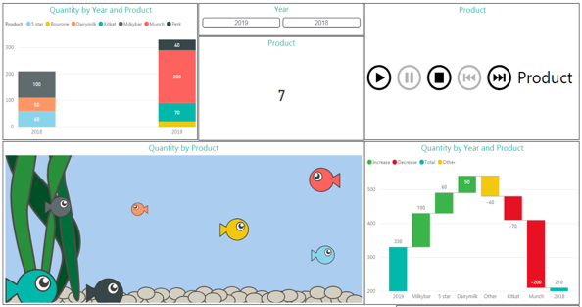

Developed by HariKrishna (diagnosed with Autism)